Frequently Asked Questions
Table of Contents
1. How to register to THDMarketplace site? 2
2. How to login? 5

How to register to THDMarketplace site?
If you are a new user, click the Register button. You will be presented with the following web page.
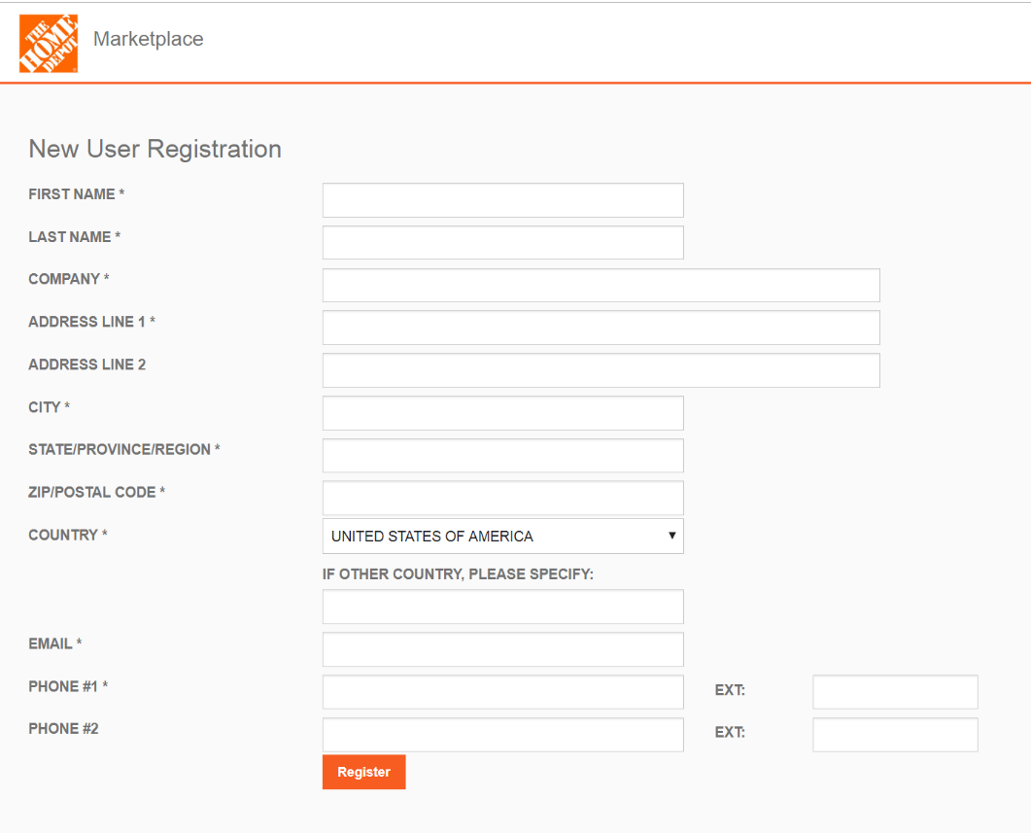

To create a new account, you will need to provide the following information as shown on the new user registration web page above.
NOTE: all data fields marked with an asterisk (*) are required.

Form Field | Description
FIRST NAME | Your first name.
LAST NAME | Your last name.
COMPANY | Name of the company you belong to.
ADDRESS LINE 1 | Your contact address line # 1
ADDRESS LINE 2 | Your contact address line # 2 (optional).
CITY | Your contact address city
STATE/PROVINCE/REGION | Your contact address State or Province or Region
ZIP/POSTAL CODE | Your contact Zip or Postal Code
COUNTRY | Your contact address Country. If your country is not listed under Country dropdown list, please enter your country name in the text field right below Country dropdown list.
EMAIL | Your company email address. It will subsequently become your user ID.  Please enter a valid email in the format - name@domain.com
PHONE #1 | Your contact Phone # 1.  Extension (EXT) is optional.
PHONE #2 | Your contact Phone # 2 (optional).  Extension (EXT) is optional.

NOTE: Please note your EMAIL address will subsequently become your user ID to log into the THD Marketplace web portal.

If no form errors occur, you will be presented with the THD Marketplace web portal - New User Registration Confirmation page shown in the following figure.

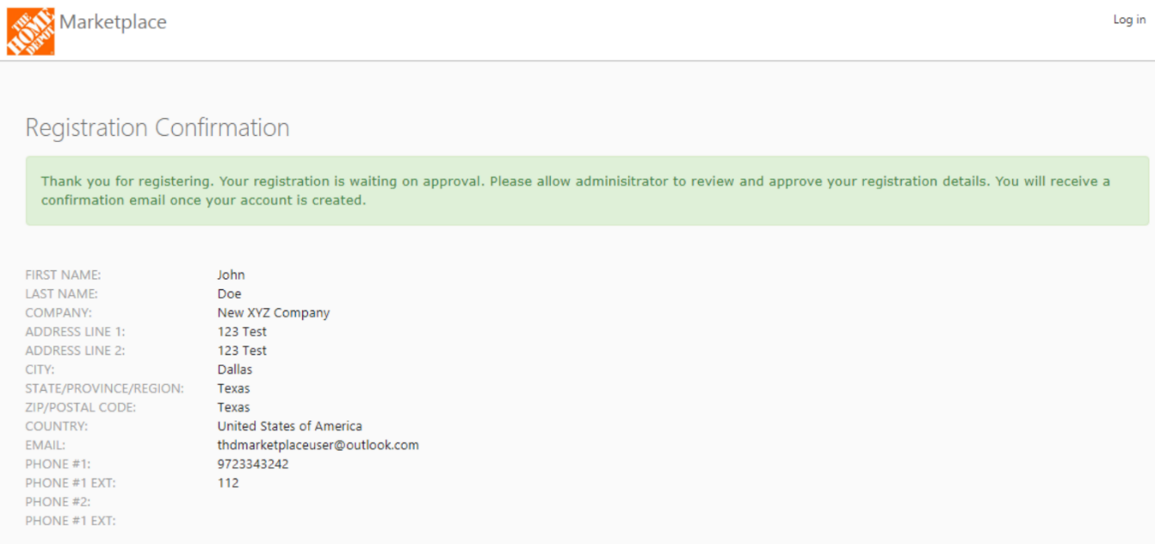

NOTE: Once you notice this successful registration confirmation as above, you will need to wait to secure access or log into THD Marketplace web portal until an administrator reviews your registration details and approves your registration.
After an administrator approves your account, you will receive an email from salvage@homedepot.com with instructions to set your new password for your new account to log into the THD Marketplace portal as shown below.

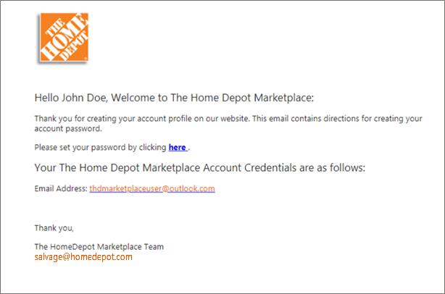

In the account password setup email that you received, click here link and you will be presented with Reset Password page as shown below.
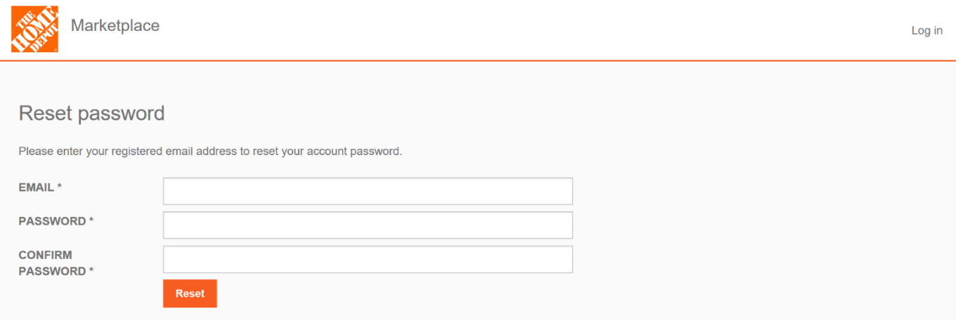

You will need to provide the following information in order to set your password on above page. All fields are required on this page. Click Reset button on this page after entering all the information.

Form Field | Description
EMAIL | Your company email address that you specified at the time of registration on this web site. This will your account user ID for The Home Depot Marketplace web portal  Please enter a valid email in the format - name@domain.com
PASSWORD | Any character string of your choice that adheres to the following criteria:  - Must be at least six (6) characters long.  - Must have at least one (1) non-letter or digit character.  - Must have at least one (1) digit (0 – 9).  - Must have at least one (1) uppercase letter (A – Z).
CONFIRM PASSWORD | Confirmation Password.  NOTE: Password and confirmation password should match.

If no form errors occur, you will be presented with Reset Password Confirmation page shown in the following view.
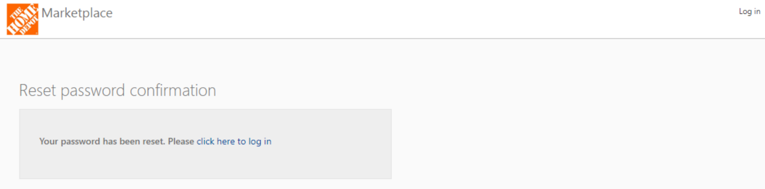

Click on the link click here to log in which will redirect you to the log in page for THD Marketplace web portal.

Please use your registered Email Address and your Password that you just reset to log into the web portal.

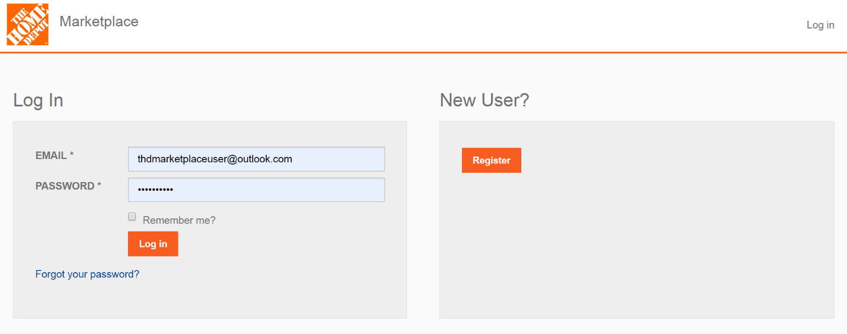

How to login?
Please use your Email Address that is registered and approved and your Password to log into the web portal. NOTE: Your registered email address has to be approved by administrator before you will be able to log into the web portal.

